CALORIE BASED BEST BREAKFAST
1. Oats Uttapam :-Uttapam is a delicious southern delight that is easy, quick and fuss-free to cook. This recipe is made with oats which makes it a healthy breakfast option which is fulfilling and satisfying. Oats are incredibly nutritious, packed with fiber and other essential nutrients. Once tried, you wouldn't need any more reasons to cook this everyday.
2. Salad We get that a salad for breakfast might be unusual but once you try this delicious recipe, we promise there's no going back. You've got chicken sausages, lettuce, eggs, tomatoes and a gorgeous honey mustard dressing.
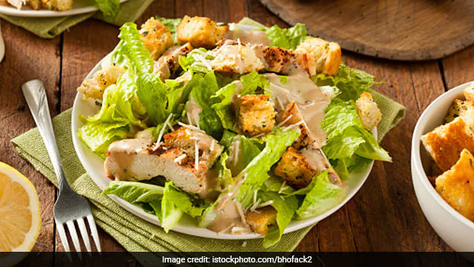
3.Melon and Kiwi Fruit Smoothie A power drink that will shoot up your energy levels instantly. Fresh fruits, milk, honey and oats come together to make this energy booster. Kiwi is a tangy and sweet fruit that has numerous benefits and when this is combined with fruits like papaya, melon and grapes, it only enhances the nutritious value of this smoothie.

4.Banana Oat Bread :- Breads are breakfast staples. But, what we don't realize is that most breads use refined flour which is high on carbs and devoid of any nutrients. Here's a simple solution, this banana and oat bread replaces all that is bad for you with all that's good.
280 Calories/
-38g Carbs/
-(32g net carbs)
-5g Fat
-20 g protein.
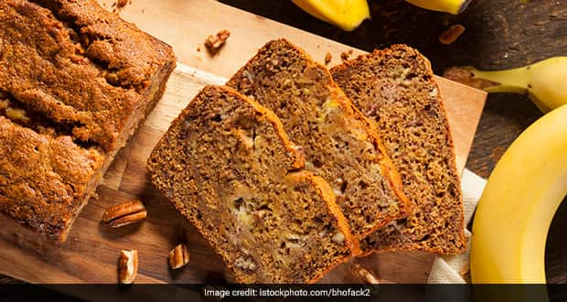
FRUIT SALAD:-
All fruits are relatively low in calories and contain good amounts of fiber and simple sugars. The fiber in fruit helps slow your body’s absorption of its sugars, giving you a steady source of energy .
- Depending on the type of fruit, you’ll also get various vitamins and minerals.
- For example, many fruits — including oranges, guava, kiwi, strawberries, papaya, acerola cherries, and lychee — are high in vitamin C, which acts as an antioxidant and plays a key role in skin health.
- Other fruits like bananas, oranges, cantaloupe, papaya, and mango are high in potassium .
