KIDS TODDLER
Food and Nutrition:
WOODWARDS:
Depending on the age and the amount of physical activity your toddler is engaged in, he needs 1000-1400 calories each day. Get the best food and nutrition recommendations here along with comprehensive food charts, healthy recipes on how to add more nutrients in your child's diet plus all that you need to know about your toddler's dietary and nutritional needs and restriction.
Is Wood wards Gripe Water Good For Babies?
gripe water was considered a herbal remedy, the Food and Drug Administration (FDA) has not approved it, but the vast majority of parents like this. It has no effect on babies suffering from colic, as it does not lessen stomach discomfort .
What Is Wood wards Gripe Water Used For?
For the symptomatic relief of distress associated with wind by infants as young as 1 year of age. It is possible to give this dosage at any point during or after each feed.
What Are The Benefits Of Wood wards?
Helps during Constipation.
The goal is to provide relief in conjunction with the teething process.
Cures Gastrointestinal issues.
Prevents Indigestion.
Lactose intolerant people are cured by this treatment.

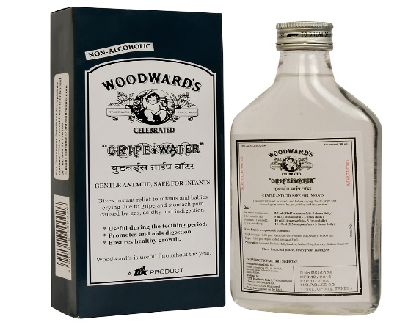
VASA KOMMU:
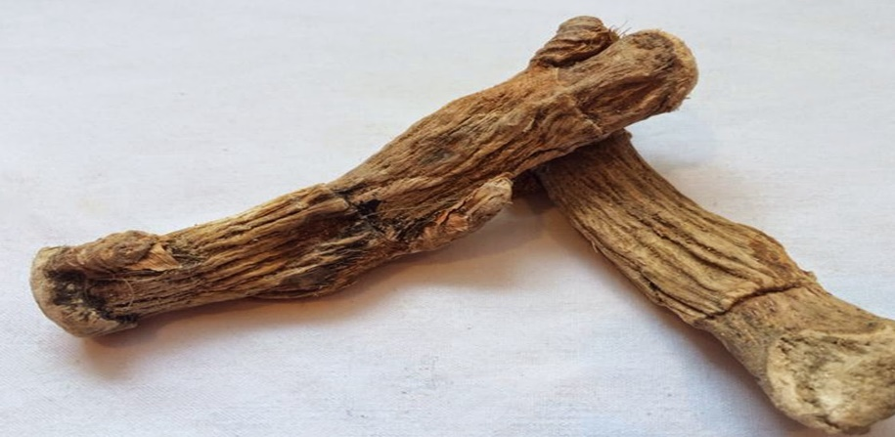
Uses: Vasa improves voice quality and relives cough. It aids in pacifying blood disorders like nasal bleeding, blood vomiting or heavy menstrual bleeding. It is used to treat fever and skin diseases. Vasa can help relieve excess thirst.
SIDE EFFECTS :
Hazards and/or side effects not known for proper therapeutic dosages. Larger doses can cause irritation and vomiting. It is not recommended during pregnancy except in assisting delivery. Ardusa/Vasaka has anti-plantation and abortifacient activities, therefore it must not be used during pregnancy.
Diet for a 6-month-old – Week 1, Day 1
Early morning Mother’s milk /formula feed
Breakfast -Stewed apple
Mid-morning -Mother’s milk /formula feed
Lunch -Mother’s milk /formula feed
Evening -Mother’s milk /formula feed
Dinner -Mother’s milk /formula feed
Diet for a 6-month-old – Week 1, Day 2
Early morning -Mother’s milk /formula feed
Breakfast - Stewed apple
Mid-morning -Mother’s milk /formula feed
Lunch -Mother’s milk /formula feed
Evening -Mother’s milk /formula feed
Dinner -Mother’s milk /formula feed

Diet for a 6-month-old – Week 1, Day 3
Early morning - Mother’s milk /formula feed
Breakfast - Stewed apple
Mid-morning -Mother’s milk /formula feed
Lunch -Mother’s milk /formula feed
Evening -Mother’s milk /formula feed
Dinner -Mother’s milk /formula feed
Diet for a 6-month-old – Week 1, Day 4
Early morning -Mother’s milk /formula feed
Breakfast -Stewed apple
Mid-morning -Mother’s milk /formula feed
Lunch -Moong dal (yellow split gram) soup
Evening -Mother’s milk /formula feed
Dinner -Mother’s milk /formula feed
Diet for a 6-month-old – Week 1, Day 5
Early morning -Mother’s milk /formula feed
Breakfast -Stewed apple
Mid-morning - Mother’s milk /formula feed
Lunch -Moong dal (yellow split gram) soup
Evening -Mother’s milk /formula feed
Dinner -Mother’s milk /formula feed
Diet for a 6-month-old – Week 1, Day 6
Early morning -Mother’s milk /formula feed
Breakfast -Stewed apple
Mid-morning -Mother’s milk /formula feed
Lunch -Moong dal (yellow split gram) soup
Evening -Mother’s milk /formula feed
Dinner -Mother’s milk /formula feed

Diet for a 6-month-old – Week 1, Day 7
Early morning - Mother’s milk /formula feed
Breakfast -Stewed pear
Mid-morning -Mother’s milk /formula feed
Lunch - Dal (lentil) -spinach soup
Evening -Mother’s milk /formula feed
Dinner -Mother’s milk /formula feed
Diet for a 6-Month-Old – Week 2, Day 1
Early morning - Mother’s milk /formula feed
Breakfast -Stewed pear
Mid-morning -Mother’s milk /formula feed
Lunch -Dal (lentil) -spinach soup
Evening -Mother’s milk /formula feed
Dinner -Mother’s milk /formula feed
Diet for a 6-Month-Old – Week 2, Day 2
Early morning -Mother’s milk /formula feed
Breakfast -Spinach-pumpkin puree
Mid-morning -Mother’s milk /formula feed
Lunch -Stewed apple
Evening -Mother’s milk /formula feed
Dinner -Mother’s milk /formula feed
Diet for a 6-Month-Old – Week 2, Day 3
Early morning Mother’s milk /formula feed
Breakfast Spinach-pumpkin puree
Mid-morning Mother’s milk /formula feed
Lunch Stewed pear
Evening Mother’s milk /formula feed
Dinner Mother’s milk /formula feed
Diet for a 6-Month-Old – Week 2, Day 4
Early morning Mother’s milk /formula feed
Breakfast Spinach-pumpkin puree
Mid-morning Mother’s milk /formula feed
Lunch Rice porridge
Evening Mother’s milk /formula feed
Dinner Mother’s milk /formula feed
Diet for a 6-Month-Old – Week 2, Day 5
Early morning Mother’s milk /formula feed
Breakfast Stewed apple
Mid-morning Mother’s milk /formula feed
Lunch Rice porridge
Evening Mother’s milk /formula feed
Dinner Mother’s milk /formula feed
Diet for a 6-Month-Old – Week 2, Day 6
Early morning Mother’s milk /formula feed
Breakfast Mashed potato
Mid-morning Mother’s milk /formula feed
Lunch Rice porridge
Evening Mother’s milk /formula feed
Dinner Mother’s milk /formula feed
Diet for a 6-Month-Old – Week 2, Day 7
Early morning Mother’s milk /formula feed
Breakfast Mashed potato
Mid-morning Mother’s milk /formula feed
Lunch Dal (lentil) -spinach soup
Evening Mother’s milk /formula feed
Dinner Mother’s milk /formula feed
Diet for a 6-Month-Old – Week 3, Day 1
Early morning Mother’s milk /formula feed
Breakfast Stewed pear
Mid-morning Mother’s milk /formula feed
Lunch Rice porridge with mashed carrot
Evening Mother’s milk /formula feed
Dinner Mother’s milk /formula feed
Diet for a 6-Month-Old – Week 3, Day 2
Early morning Mother’s milk /formula feed
Breakfast Spinach-pumpkin puree
Mid-morning Mother’s milk /formula feed
Lunch Rice porridge with mashed carrot
Evening Mother’s milk /formula feed
Dinner Mother’s milk /formula feed
Diet for a 6-Month-Old – Week 3, Day 3
Early morning Mother’s milk /formula feed
Breakfast Stewed apple
Mid-morning Mother’s milk /formula feed
Lunch Rice porridge with mashed carrot
Evening Mother’s milk /formula feed
Dinner Mother’s milk /formula feed
Diet for a 6-Month-Old – Week 3, Day 4
Early morning Mother’s milk /formula feed
Breakfast Carrot-beetroot puree
Mid-morning Mother’s milk /formula feed
Lunch Spinach-pumpkin puree
Evening Mother’s milk /formula feed
Dinner Mother’s milk /formula feed
Diet for a 6-Month-Old – Week 3, Day 5
Early morning Mother’s milk /formula feed
Breakfast Carrot-beetroot puree
Mid-morning Mother’s milk /formula feed
Lunch Dal (lentil) -spinach soup
Evening Mother’s milk /formula feed
Dinner Mother’s milk /formula feed
Diet for a 6-Month-Old – Week 3, Day 6
Early morning Mother’s milk /formula feed
Breakfast Carrot-beetroot puree
Mid-morning Mother’s milk /formula feed
Lunch Stewed pear
Evening Mother’s milk /formula feed
Dinner Mother’s milk /formula feed
Diet for a 6-Month-Old – Week 3, Day 7
Early morning Mother’s milk /formula feed
Breakfast Rice porridge with mashed carrot
Mid-morning Mother’s milk /formula feed
Lunch
Lauki (bottle gourd)- moong dal (green gram split) soup
Evening Mother’s milk /formula feed
Dinner Mother’s milk /formula feed
Diet for a 6-Month-Old – Week 4, Day 1
Early morning Mother’s milk /formula feed
Breakfast Mashed potato
Mid-morning Mother’s milk /formula feed
Lunch
Lauki (bottle gourd) moong dal ( green gram split) soup
Evening Mother’s milk /formula feed
Dinner Mother’s milk /formula feed
Diet for a 6-Month-Old – Week 4, Day 2
Early morning Mother’s milk /formula feed
Breakfast
Sweet potato + poha (flattened rice) powder
Mid-morning Mother’s milk /formula feed
Lunch Tomato- pumpkin soup
Evening Mother’s milk /formula feed
Dinner Mother’s milk /formula feed
Diet for a 6-Month-Old – Week 4, Day 3
Early morning Mother’s milk /formula feed
Breakfast
Sweet potato + poha (flattened rice) powder
Mid-morning Mother’s milk /formula feed
Lunch Lauki (bottle gourd) rice
Evening Mother’s milk /formula feed
Dinner Mother’s milk /formula feed
Diet for a 6-Month-Old – Week 4, Day 4
Early morning Mother’s milk /formula feed
Breakfast
Sweet potato + poha (flattened rice) powder
Mid-morning Mother’s milk /formula feed
Lunch
Rice porridge with mashed carrot
Evening Mother’s milk /formula feed
Dinner Mother’s milk /formula feed
Diet for a 6-Month-Old – Week 4, Day 5
Early morning Mother’s milk /formula feed
Breakfast Dal (lentil) -spinach soup
Mid-morning Mother’s milk /formula feed
Lunch Palak (spinach)khichdi
Evening Mother’s milk /formula feed
Diet for a 6-Month-Old – Week 4, Day 6
Early morning Mother’s milk /formula feed
Breakfast Mashed potato
Mid-morning Mother’s milk /formula feed
Lunch
Ragi (finger millet) – moong dal (green gram split) soup
Evening Mother’s milk /formula feed
Dinner Mother’s milk /formula feed
Diet for a 6-Month-Old – Week 4, Day 7
Early morning Mother’s milk /formula feed
Breakfast Spinach-pumpkin puree
Mid-morning Mother’s milk /formula feed
Lunch
Ragi (finger millet) – moong dal (green gram split) soup
Evening Mother’s milk /formula feed
Dinner Mother’s milk /formula feed

