SUMMER COOLER -NATURAL WITH NO SIDE EFFECTS
buttermilk is an all-time favourite that people in Indian households often have it along with lunch for better absorption and digestion With spices like red chillies, mustard seeds, cumin seeds and curry leaves.

CUCUMBERS:

Summer salads are incomplete without a generous addition of cucumbers. This water based vegetable is a great way to cool off, while getting the adequate amount of nutrients as well. Cucumbers are high on antioxidants, vitamins and minerals making it the ideal summer treat. The vegetable can be had with a pinch of salt and pepper or it can be part of salads as well with other vegetables. Cucumber juice is also an excellent way to stay fit and cool during the summers.
WATERMELON:
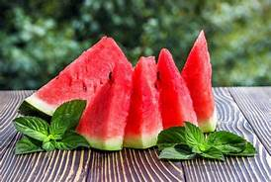
This super fruit, with 92% water content is the king of summer fruits with its innumerable qualities. Given its high water content, watermelons make an excellent addition in one’s diet during summer. Watermelon can be consumed as a fruit, in salads, juices, can be mixed with other fruits like mango or a refreshing fruity mocktail.
Jal Jeera:
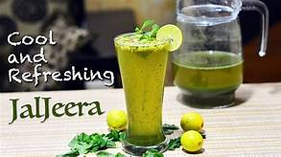
Jal Jeera is made of water and cumin seeds (Jeera) primarily, is perfect for the summer and reduces gastric issues. Apart from crushed cumin seeds, the beverage contains mint leaves, coriander leaves, black salt and lemon juice making it tangy and refreshing. Jal Jeera is a popular welcome drink, appetizer and a tasty accompaniment for lunch or dinner.
LEMON BARLEY WATER:
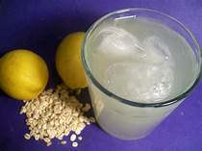
It is one of the oldest drinks used by ancient Egyptians to cool their bodies during summer. It helps maintain body temperature. It also acts as a natural remedy to reduce kidney stones and clear off Urinary Tract Infection. Due to its fiber content, it helps weight loss, improves metabolism and keeps the digestive system healthy.
Orange Green Tea:

This is a Darjeeling green tea nicely blended with orange peels, touched with a natural flavour of orange and lemon grass gives a hydrating cooling effect in the torrid heat. The summer season is the right time to go for a zesty orange green tea. It is an incredible summer cooler that leaves a tangy calming effect. Just keep tea leaves in hot water for 5 minutes, refrigerate and serve chilled decked up with some sugar.

